VENETIAN BLINDS INSTALLATION GUIDE
1. INSIDE FIT
Place the brackets 10 mm inside from outer edge (figure 1) and fix each with 3 -4 screws (6-8 gauge, 15 – 25 mm long). Be sure that both brackets are fixed the same distance from outer/internal edge. You can place the bracket deeper inside of the frame but watch for handles, mullions or security stays to clear.

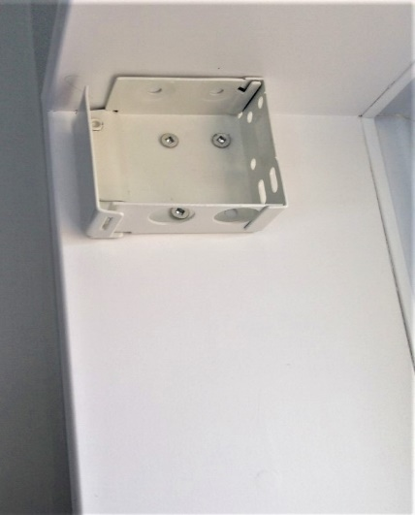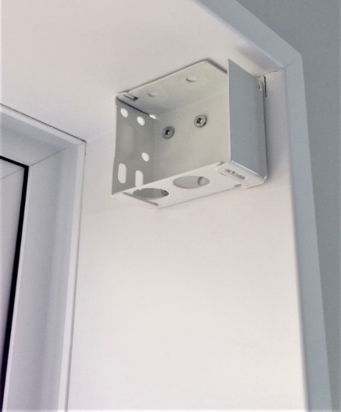
Figure 1 Figure 1

2. FACE FIT
Fix the bracket on an architrave or wall (figure 2) with 3-4 screws (6-8 gauge, 15 – 50 mm long). Be sure that both brackets are on the same level and there is a solid fixing (wooden architrave, wall studs). Use giboard / wall plugs if you can’t fix the brakets to the wall studs.
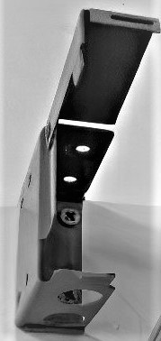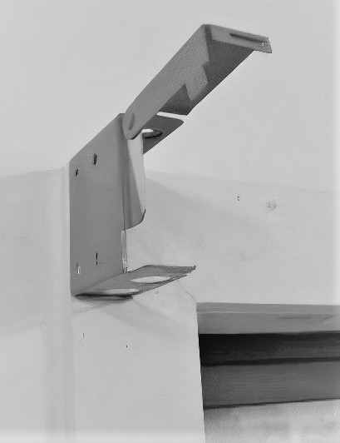
Figure 2 Figure 2

3. SUPPORT BRACKETS
Support Bracket (figure 3) is used if width of the venetian blind is greater than 2 000 mm. Use 2 or 3 screws (6-8 gauge, 15 – 25 mm long) and align the centre support bracket with brackets in the corners. Check the string locations of the blind to ensure the placement of the support bracket is not in the way.

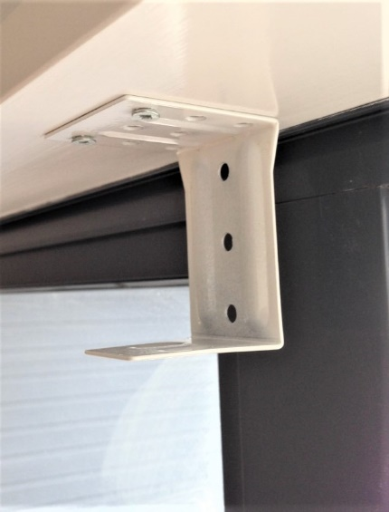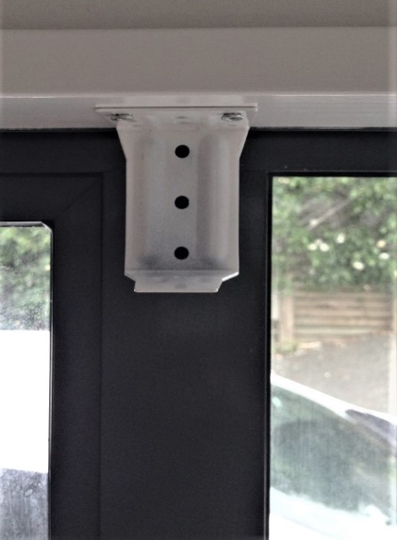
Figure 3 Figure 3

4. BLINDS FITTING
- When the side brackets and support bracket/s are istalled open the front flaps of the brackets (figure 4).
- Having the blind pulled up will allow for easier lifting and fitting (figure 5).

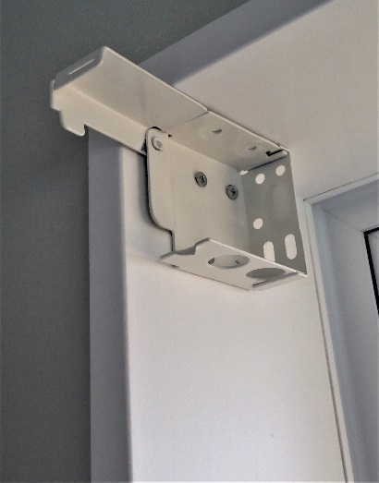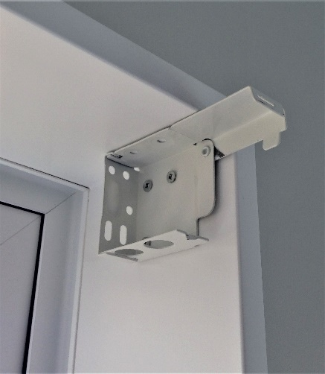
Figure 4 Figure 4
- Slide the headrail into the brackets from the front as shown on figure 5.
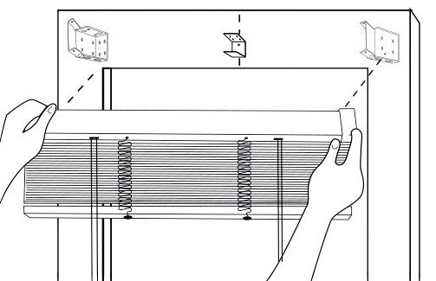
Figure 5
- Once the headrail is placed inside of the brackets, lower the front flaps to secure its placement. Be sure that the flaps are closed well to prevent the blind falling off when it is used (figure 6).

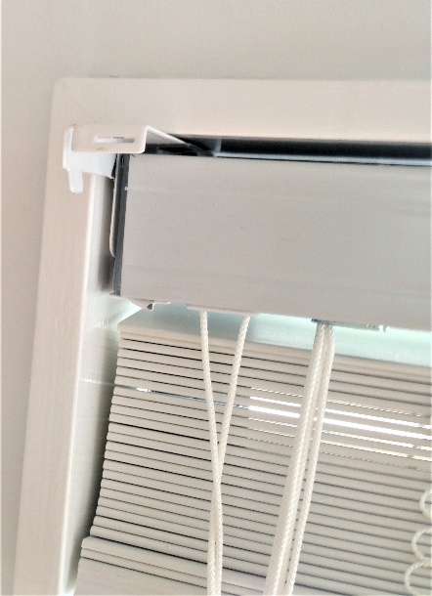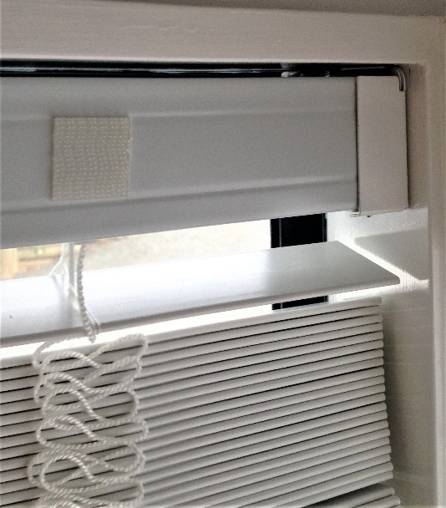
Figure 5 Figure 6
- Remove the covering tapes from the pre-attached Velcro on the front of the headrail (figure 7). There would be 3 or more depends on size.
- Press fascia / valance firmly onto the headrail leaving same gap all the way if possible (figure 8).

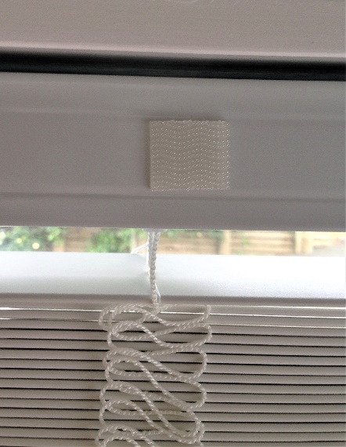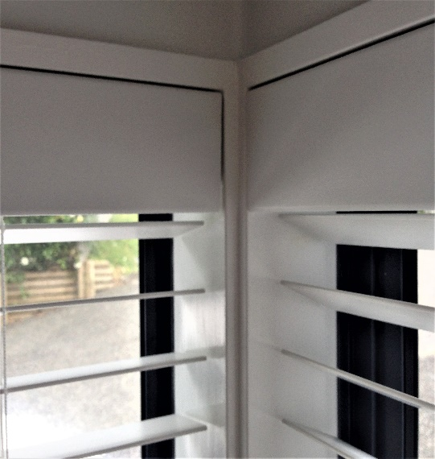
Figure 7 Figure 8

